Probabilities at which statin therapy for primary prevention of CVD is likely to provide net benefits among 350 subgroups based on age, sex, and CVD risk (1% to 25%).

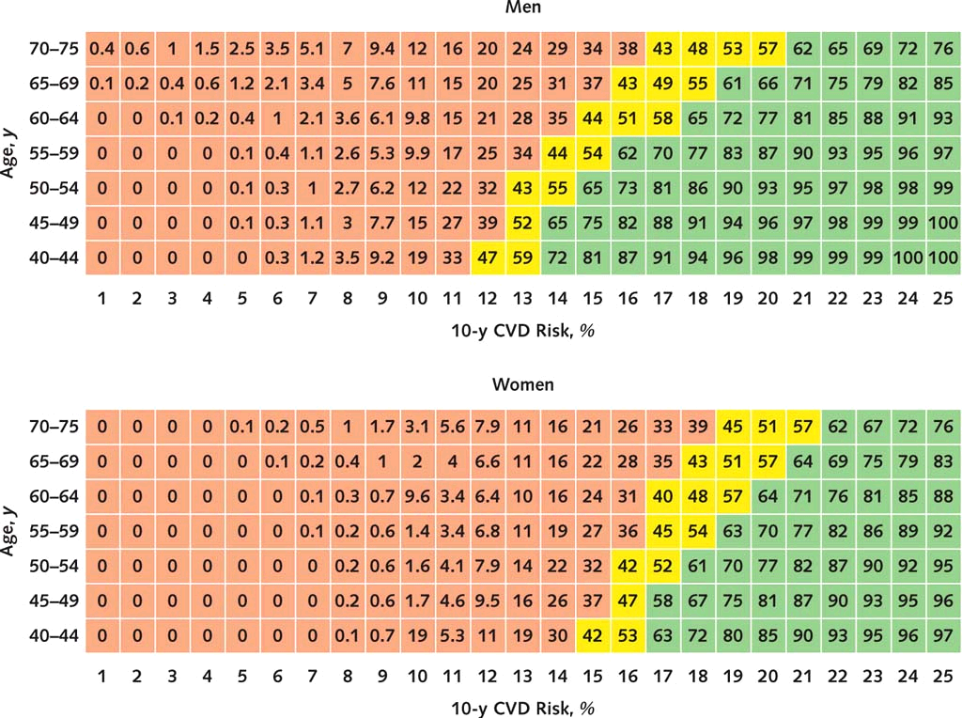

Pink cells indicate risk thresholds that harms outweigh benefits (<40%).
Yellow cells indicate risk thresholds that harms equal benefits (40% to 60%).
Green cells indicate risk thresholds that benefits outweigh harms (≥60%).

Probabilities at which statin therapy for primary prevention of CVD is likely to provide net benefits among 1120 subgroups of men based on age, CVD risk (1% to 40%), and statin type.

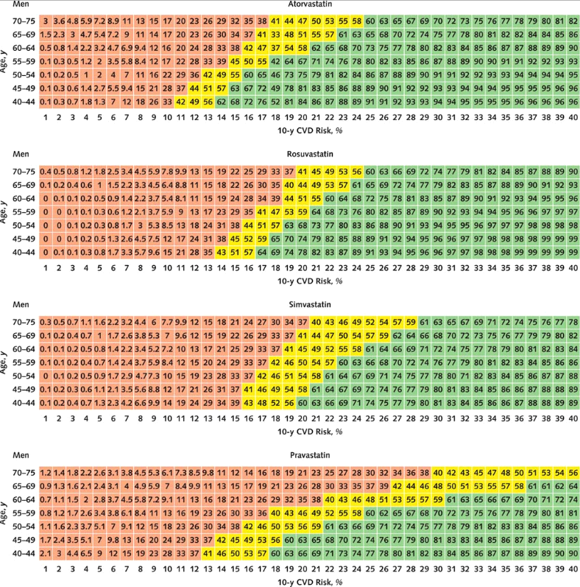

Pink cells indicate risk thresholds that harms outweigh benefits (<40%).
Yellow cells indicate risk thresholds that harms equal benefits (40% to 60%).
Green cells indicate risk thresholds that benefits outweigh harms (≥60%).

Probabilities at which statin therapy for primary prevention of CVD is likely to provide net benefits among 1120 subgroups of women based on age, CVD risk (1% to 40%), and statin type.

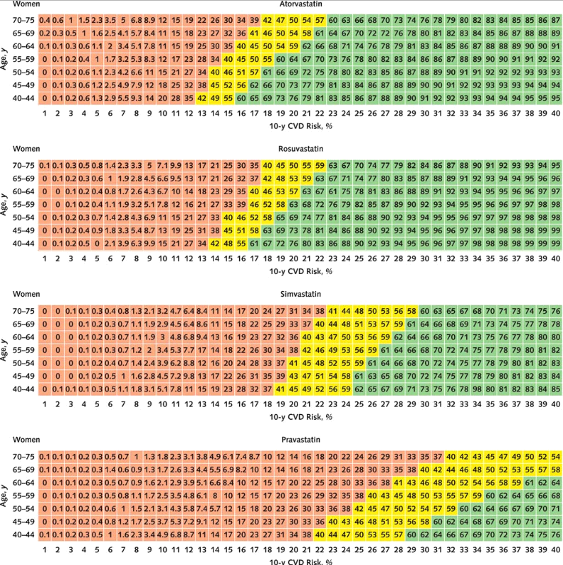
Pink cells indicate risk thresholds that harms outweigh benefits (<40%).
Yellow cells indicate risk thresholds that harms equal benefits (40% to 60%).
Green cells indicate risk thresholds that benefits outweigh harms (≥60%).

